**HANDS ON WEEK 6**

**REACT**

**ReactJS-HOL**

**1: Create a new React Application with the name “myfirstreact”, Run the application to print “welcome to the first session of React” as heading of that page.**

**CODE :**

import logo from './logo.svg';

import './App.css';

function App() {

return (

<div style={{ textAlign: 'center' }}>

<h1>Welcome the first session of React</h1>

</div>

);

}

export default App;

**OUTPUTS :**

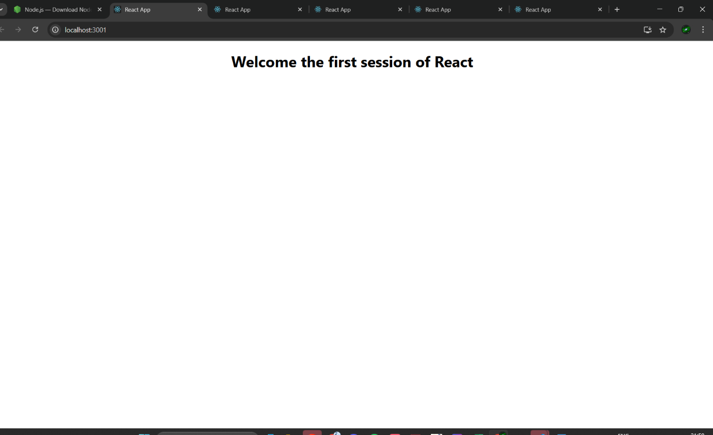

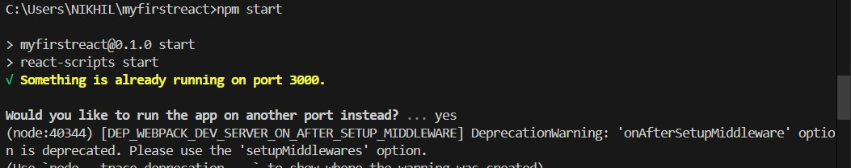

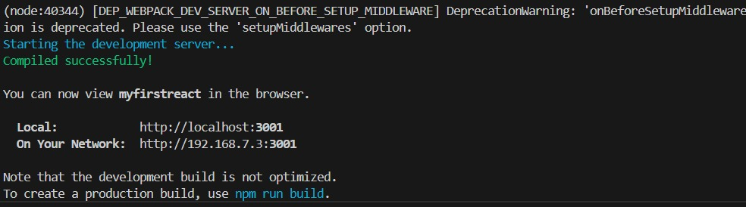

**2 : Create a react app for Student Management Portal named StudentApp and create a component named Home which will display the Message “Welcome to the Home page of Student Management Portal”. Create another component named About and display the Message “Welcome to the About page of the Student Management Portal”. Create a third component named Contact and display the Message “Welcome to the Contact page of the Student Management Portal”. Call all the three components.**

**CODE :**

**APP.JS :**

// src/App.js

import logo from './logo.svg';

import './App.css';

import Home from './Components/Home';

import About from './Components/About';

import Contact from './Components/Contact';

function App() {

return (

<div className="container">

<Home />

<About />

<Contact />

</div>

);

}

export default App;

**HOME.JS :**

// src/Components/Home.js

import React, { Component } from 'react';

class Home extends Component {

render() {

return (

<div style={{ textAlign: 'center' }}>

<h3>Welcome to the Home Page of Student Management Portal</h3>

</div>

);

}

}

export default Home;

**CONTACT.JS :**

// src/Components/Contact.js

import React, { Component } from 'react';

class Contact extends Component {

render() {

return (

<div style={{ textAlign: 'center' }}>

<h3>Welcome to the contact page of Student Management Portal</h3>

</div>

);

}

}

export default Contact;

**ABOUT.JS :**

// src/Components/About.js

import React, { Component } from 'react';

class About extends Component {

render() {

return (

<div style={{ textAlign: 'center' }}>

<h3>Welcome to the About Page of Student Management Portal</h3>

</div>

);

}

}

export default About;

**OUTPUTS:**

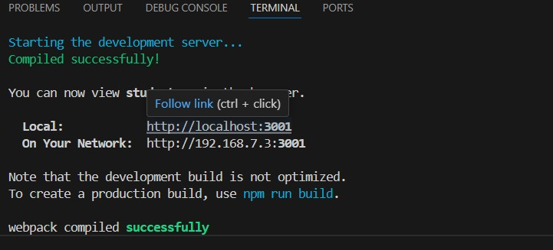

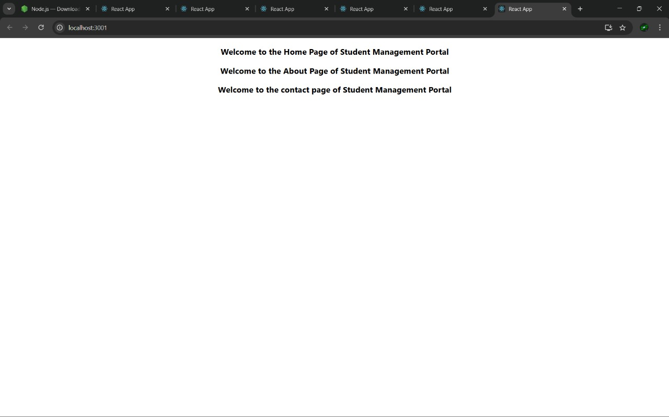

**3:Create a react app for Student Management Portal named scorecalculatorapp and create a function component named “CalculateScore” which will accept Name, School, Total and goal in order to calculate the average score of a student and display the same.**

**App.js:**

import logo from './logo.svg';

import { CalculateScore } from './Components/CalculateScore';

function App() {

return (

<div>

<CalculateScore

Name="Steeve"

School="DNV Public School"

total={284}

goal={300}

/>

</div>

);

}

export default App;

**MY STYTLE.CSS :**

.Name {

font-weight: 300;

color:blue;

}

.School {

color: crimson;

}

.Total {

color: darkmagenta;

}

.formatstyle {

text-align: center;

font-size: large;

}

**CALCULATE SCORE.JS :**

.Score {

color: forestgreen;

}

import '../Stylesheets/mystyle.css';

const percentToDecimal = (decimal) => {

return (decimal * 100).toFixed(2) + '%';

};

const calcScore = (total, goal) => {

return percentToDecimal(total / goal);

};

export const CalculateScore = ({ Name, School, total, goal }) => (

<div className="formatstyle">

<h1><font color="Brown">Student Details:</font></h1>

<div className="Name">

<b><span>Name: </span></b>

<span>{Name}</span>

</div>

<div className="School">

<b><span>School: </span></b>

<span>{School}</span>

</div>

<div className="Total">

<b><span>Total: </span></b>

<span>{total}</span>

<span> Marks</span>

</div>

<div className="Score">

<b>Score: </b>

<span>{calcScore(total, goal)}</span>

</div>

  </div>

);

**OUTPUTS :**

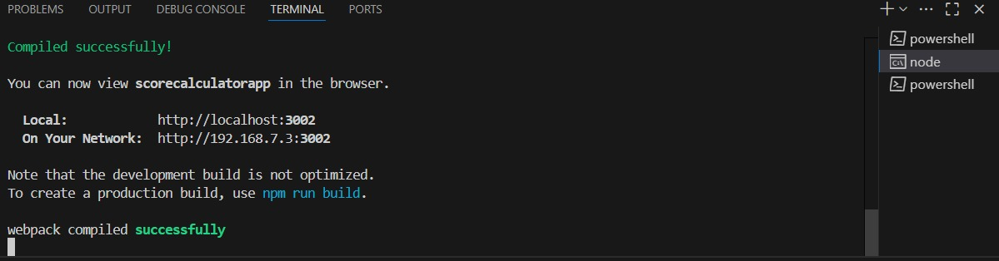

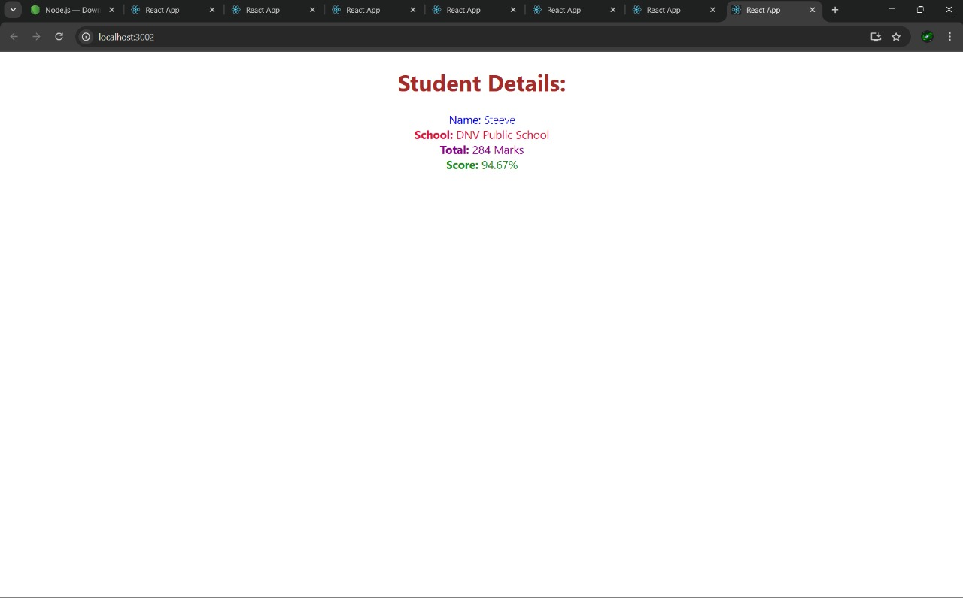

**4 : REACT JS HOL HANDSON 4**

**APP.JS :**

// src/App.js

import React from 'react';

import Posts from './Posts';

function App() {

return (

<div className="App">

<Posts />

</div>

);

}

export default App;

**POSTS.JS :**

// src/Posts.js

import React, { Component } from 'react';

import Post from './Post';

class Posts extends Component {

constructor(props) {

super(props);

this.state = {

posts: [],

hasError: false,

};

}

componentDidMount() {

this.loadPosts();

}

loadPosts() {

fetch('https://jsonplaceholder.typicode.com/posts')

.then((res) => res.json())

.then((data) => this.setState({ posts: data }))

.catch((error) => {

console.error('Error loading posts:', error);

this.setState({ hasError: true });

});

}

componentDidCatch(error, info) {

alert('An error occurred: ' + error.toString());

}

render() {

const { posts, hasError } = this.state;

if (hasError) {

return <h2 style={{ color: 'red' }}>Something went wrong while loading posts.</h2>;

}

return (

<div>

<h1>Blog Posts</h1>

{posts.slice(0, 10).map((post) => (

<Post key={post.id} title={post.title} body={post.body} />

))}

</div>

);

}

}

export default Posts;

**POST.JS :**

// src/Post.js

import React from 'react';

const Post = ({ title, body }) => {

return (

<div style={{ border: '1px solid #ccc', padding: '12px', margin: '10px' }}>

<h3>{title}</h3>

<p>{body}</p>

</div>

);

};

export default Post;

**OUTPUT :**

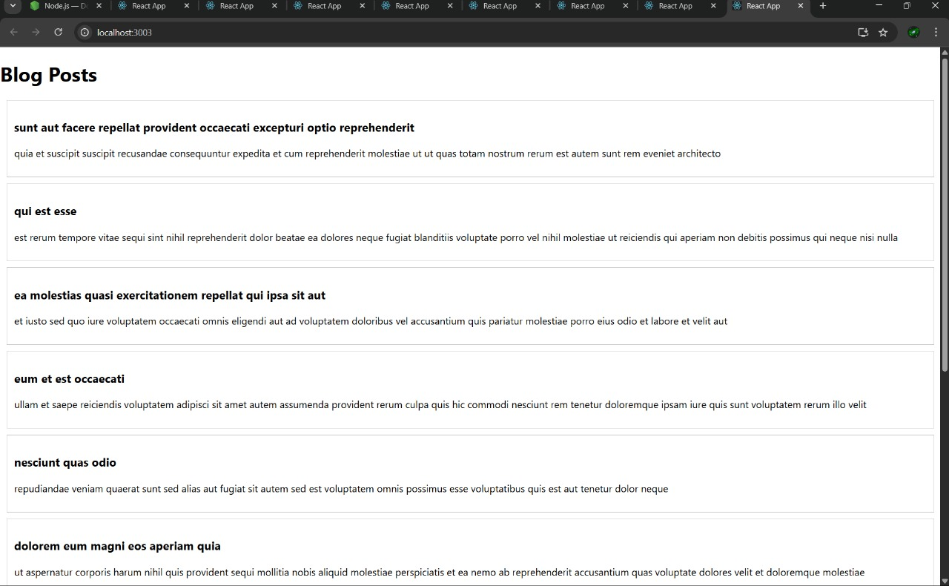

**5 : My Academy team at Cognizant want to create a dashboard containing the details of ongoing and completed cohorts. A react application is created which displays the detail of the cohorts using react component. You are assigned the task of styling these react components.**

**APP.JS :**

import React from 'react';

import CohortDetails from './components/CohortDetails';

function App() {

return (

<div>

<CohortDetails name="React Basics" status="ongoing" duration="4 Weeks" />

<CohortDetails name="Java Advanced" status="completed" duration="6 Weeks" />

<CohortDetails name="Data Structures" status="ongoing" duration="5 Weeks" />

</div>

);

}

export default App;

**COHORT DETAILS.MODULE.CSS :**

.box {

width: 300px;

display: inline-block;

margin: 10px;

padding: 10px 20px;

border: 1px solid black;

border-radius: 10px;

}

dt {

font-weight: 500;

}

**COHORT DETAILS :**

import React from 'react';

import styles from '../styles/CohortDetails.module.css';

const CohortDetails = ({ name, status, duration }) => {

const headingStyle = {

color: status === 'ongoing' ? 'green' : 'blue',

};

return (

<div className={styles.box}>

<h3 style={headingStyle}>{name}</h3>

<dl>

<dt>Status</dt>

<dd>{status}</dd>

<dt>Duration</dt>

<dd>{duration}</dd>

</dl>

</div>

);

};

export default CohortDetails;

**OUTPUT :**

